Prepared by: Bharath Nanduri  
Prepared for: Product Manager, Systems Admin

**Project Scheduling Assignment**

**Network Diagram:**

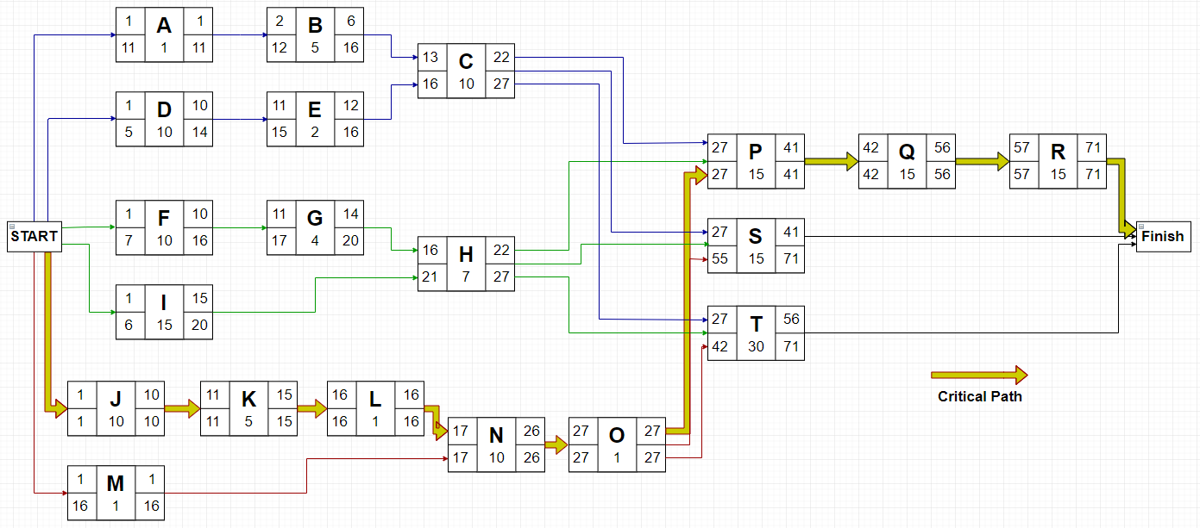

List of Tasks , Time Estimates(PERT), and Expected Time.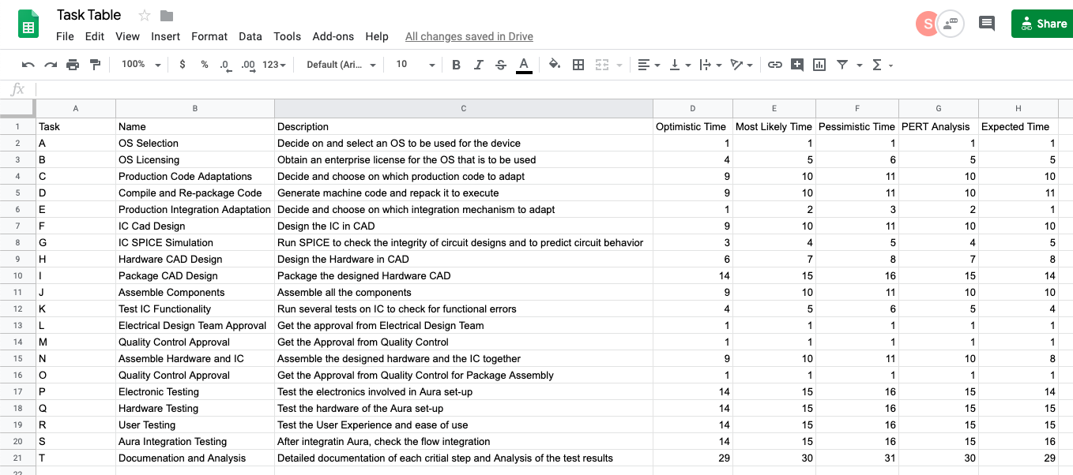

**Microsoft Project:** Tasks, duration, milestones. Slack time in the Gantt chart.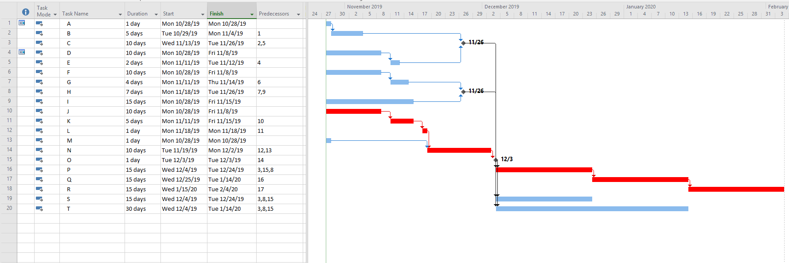

**Critical Path = Red Path**

**Milestones:**

10/28: Project Starts

11/26: Hardware and Software Programming Completed

11/26: Product Design Finalized and Completed

12/3: Product Development and Assembly Completed.

2/3: Project Completed